
Company
Logotype

Cone Beam Computed Tomography- Report



Porur Dental X-rays & CBCT

Patient Name : Mrs. Umayal | Date of Report : 15.03.2024
Age/ Gender : 65 years/ Female | Region of Interest : CBCT Full Skull
Referring doctor: Dr. Raji Selvaraj | Indication : Nil
Clinical Notes: Nil
PATIENT INFORMATION

CBCT- Full skull provided
CBCT – IMAGE DETAILS

RADIOGRAPHIC INTERPRETATION

- Presence of hyperdense screw like structures (dental implant) in relation to 11, 12, 14, 2 nos in right pterygoid plates, 24, 25, 26, 1 no in left pterygoid plate, 31, 36, 37, 41, 43, 46, 48 region.
- The alveolar bone in relation to the placed implants are present with normal trabecular pattern.
- The implant in relation to 36 region is present at a distance of 2.6 mm from the inferior alveolar nerve canal.
- The implant in relation to 37 region is present at a distance of 5.3 mm from the inferior alveolar nerve canal.
- The implant in relation to 46 region is present in close proximity to the inferior alveolar nerve canal.
- The implant in relation to 48 region is present at a distance of 2.4 mm from the inferior alveolar nerve canal.

RADIOGRAPHIC IMPRESSION

- Dental implants in relation to 11, 12, 14, 2 nos in right pterygoid plates, 24, 25, 26, 1 no in left pterygoid plate, 31, 36, 37, 41, 43, 46, 48 region.

Kindly correlate with clinical findings


IMAGES FOR REFERENCE

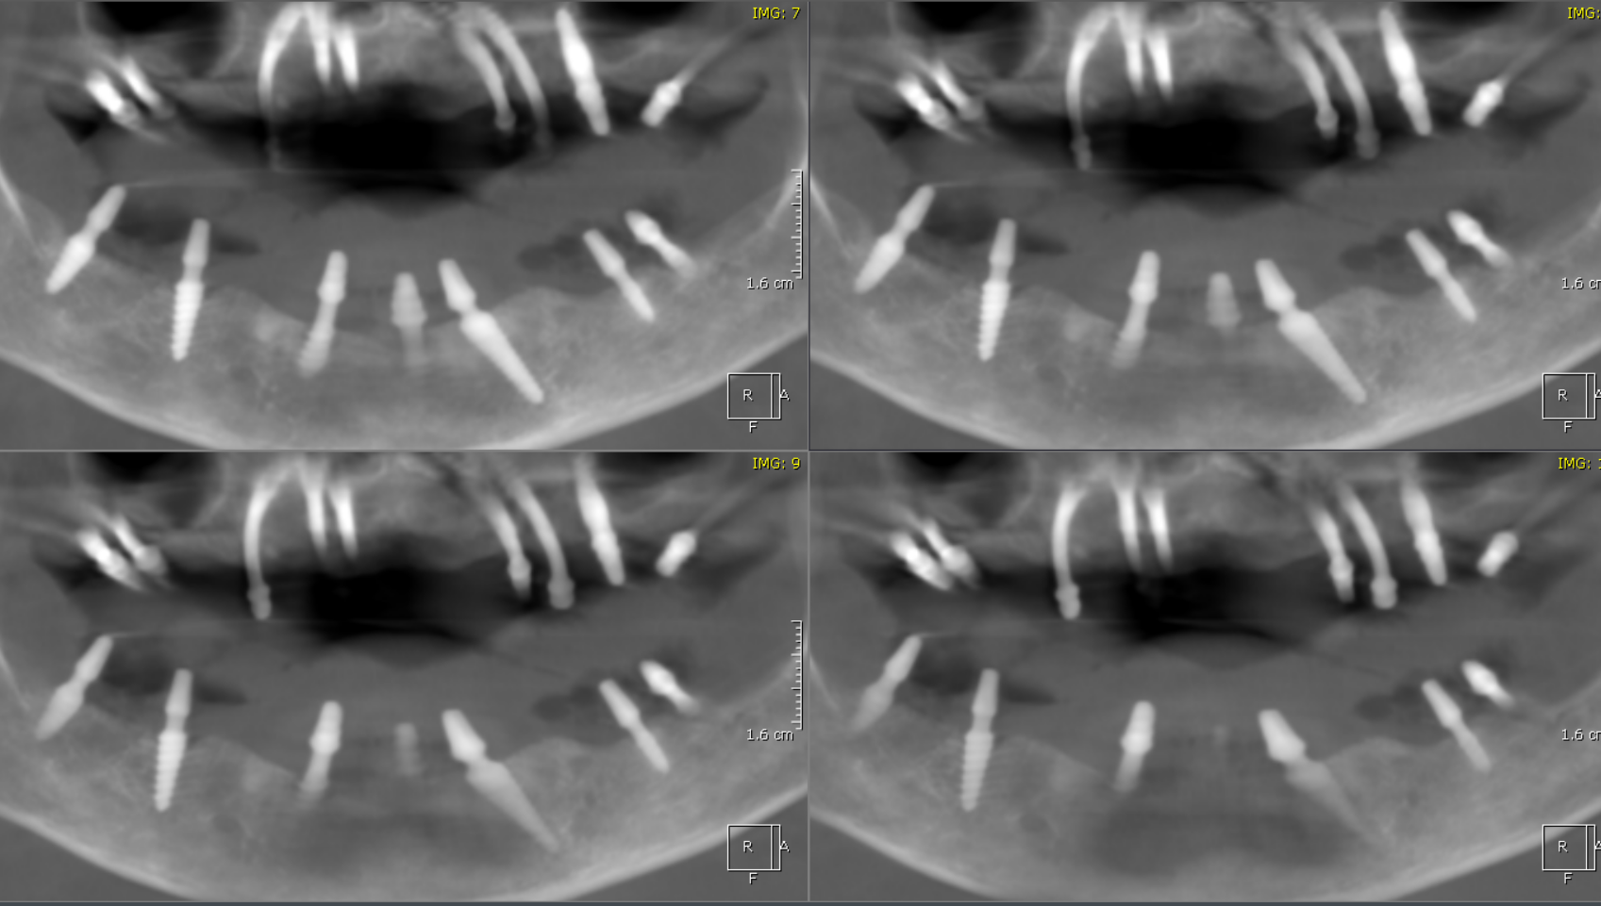

3-DIMENSIONAL VIEW

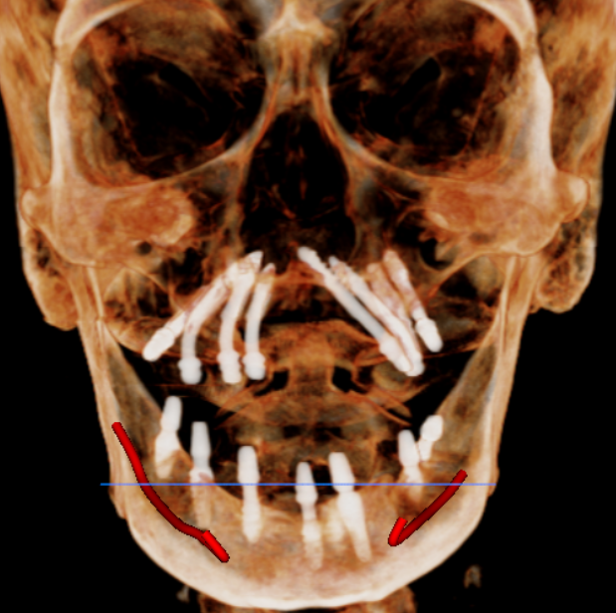

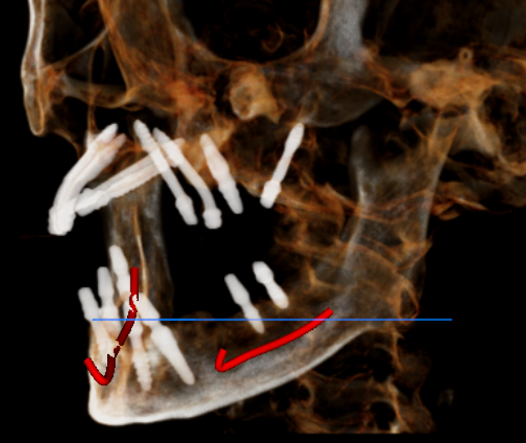
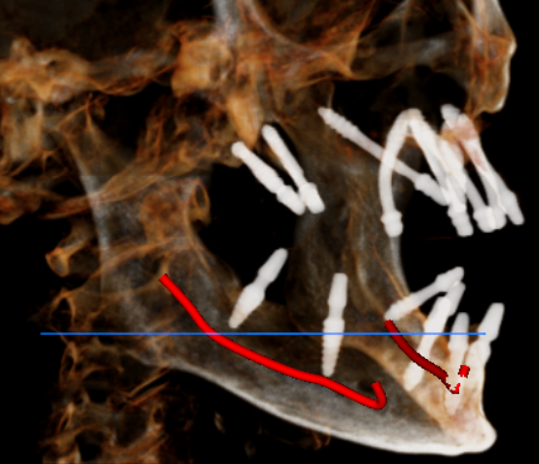

CROSS SECTIONAL VIEW
46 region | 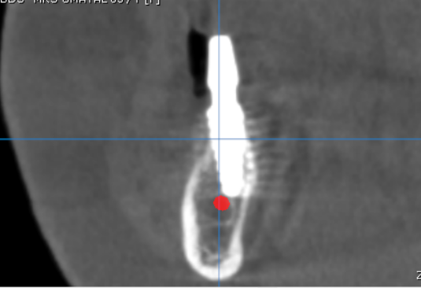
48 region | 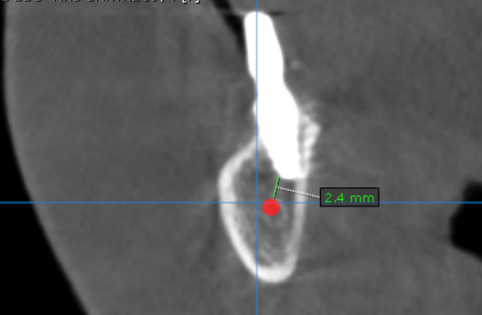
36 region | 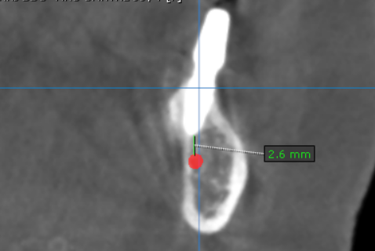
37 region | 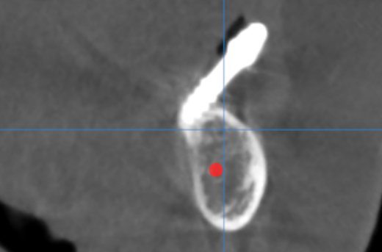

**** End of report ****

